**Indian Institute of Technology Guwahati**

**Department of Civil Engineering**

CE 101- Engineering Drawing

Tutorial 8: Intersection of Solids

Q1. Solution:

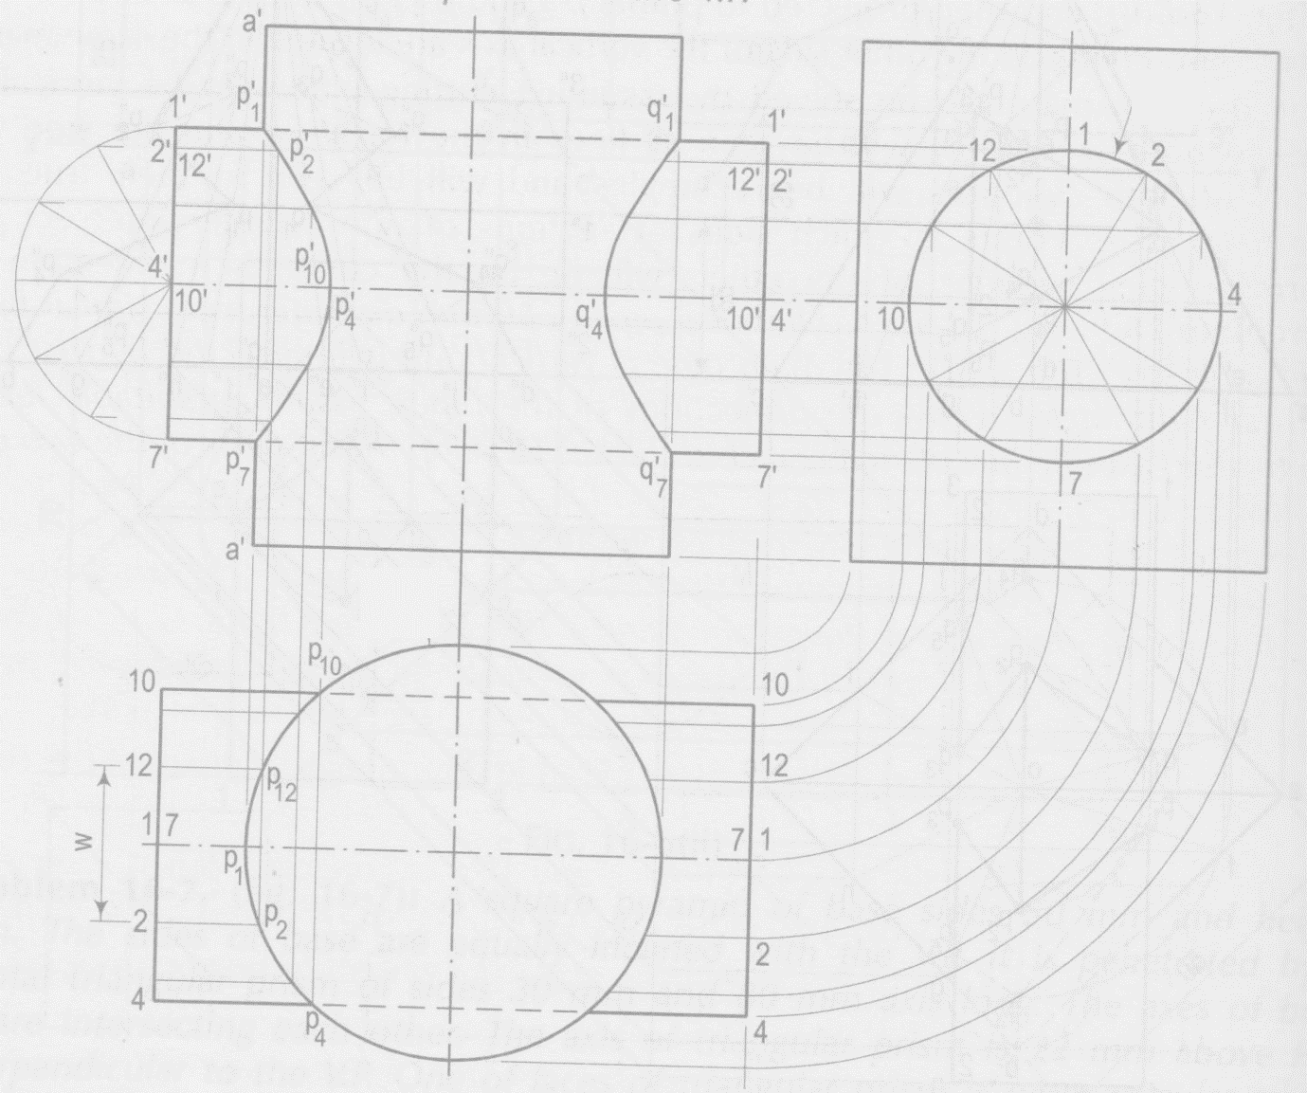

Q2. Solution:

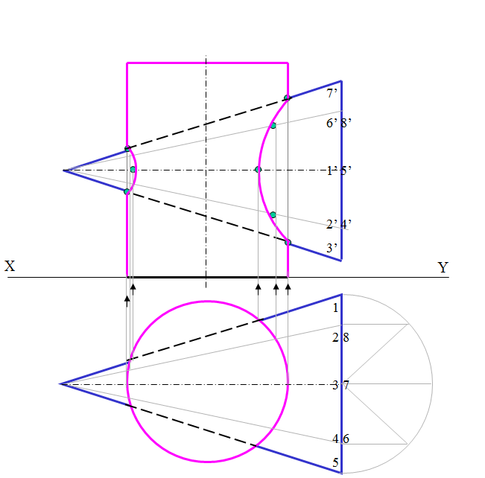

**Please note that ‘arrows’ and ‘dots’ are not essential to be shown by the students in the solution. These are just for the understanding of students and TAs.**